

OSSP INDIDUAL ASSIGMENET

SYLABLLE OS

NAME ID

ROBEL AGMAS BDU1602334

Submission date 16/08/17

Submitted to wendmu baye

INTRODUCION(BACKGRUOND AND MOTIVATION.

Conceptual Overvie

The "Syllable Operating System) is based on the idea that core functions, data structures, and user interfaces are all represented by syllables containing the "op" sound. The system would run on a fictitious computer built with "syllable chips."These would be the fundamental instructions the system understands. Here are some examples:

• Op-en: To open a file or application.

• Op-er-ate: The core "do something" command.

• Op-tion: For making choices or setting preferences.

• Op-pose: To cancel or undo an action.

• Op-por-tune: To schedule or delay tasks.

• Op-u-lent: To create/duplicate or expand memory.

Data Structures (File Types/Objects):

Files and data would also be named using "op" syllables:

• Op-us: A document or text file.

• Op-tic: An image file.

• Op-code: A program or executable file.

• Op-era: An audio file.

• Op-al: A configuration file.

• Op-tion-al : A package or directory.

User Interface (UI Elements):

The user interacts with the system through syllable-based elements:

• Buttons: "Op-press" (to click)

• Menus: "Op-tions"

• Prompts: "Op-in-ion?" (requiring user input)

• Notifications: "Op-er-a-tion!" (to alert the user)

• Scroll bars: "Op-po-site" (direction of scroll)

• Loading: "Op-ti-mize"

Error Messages:

• "Op-stacle!" (Something is blocking the program.)

• "Op-posed!" (The action is denied)

• "Op-er-a-tor Error"

Example Interaction:

Imagine opening a text file (an "Op-us"):

1. The user types: "Op-en Op-us (filename)"

2. The system responds: "Op-er-ate!" (indicating the file is opening)

3. The file opens and displays on the screen.

Humorous Considerations:

• Debugging would involve finding "Op-sies" in the code.

• The operating system might be described as "Op-ti-mistic" or "Op-er-a-tional."

• A virus could be called an "Op-po-nent."

Why it's interesting (but not practical):

• Constraints Force Creativity: The limitation of using only "op" syllables forces creative thinking about how to represent complex concepts.

• Highlights Language's Flexibility: It demonstrates how language can be used metaphorically and artistically.

* • Playful Exploration: It's a fun way to explore the relationship between language, technology, and imagination.

In Conclusion:

SyllabOS is a whimsical idea that highlights the power and flexibility of language. While it's not a real operating system, it's a thought experiment that encourages creative thinking about how language can be used in unexpected ways. It's a reminder that even the most fundamental units of language, like syllables, can be used to build complex and imaginative structures.

Core Syllables (Commands/Functions):

These would be the fundamental instructions the system understands. Here are some examples:

• Op-en: To open a file or application.

• Op-er-ate: The core "do something" command.

• Op-tion: For making choices or setting preferences.

• Op-pose: To cancel or undo an action.

• Op-por-tune: To schedule or delay tasks.

• Op-u-lent: To create/duplicate or expand memory.

Data Structures (File Types/Objects):

Files and data would also be named using "op" syllables:

• Op-us: A document or text file.

• Op-tic: An image file.

• Op-code: A program or executable file.

• Op-era: An audio file.

• Op-al: A configuration file.

• Op-tion-al : A package or directory.

User Interface (UI Elements):

The user interacts with the system through syllable-based elements:

• Buttons: "Op-press" (to click)

• Menus: "Op-tions"

• Prompts: "Op-in-ion?" (requiring user input)

• Notifications: "Op-er-a-tion!" (to alert the user)

• Scroll bars: "Op-po-site" (direction of scroll)

• Loading: "Op-ti-mize"

Error Messages:

• "Op-stacle!" (Something is blocking the program.)

• "Op-posed!" (The action is denied)

• "Op-er-a-tor Error"

Example Interaction:

Imagine opening a text file (an "Op-us"):

1. The user types: "Op-en Op-us (filename)"

2. The system responds: "Op-er-ate!" (indicating the file is opening)

3. The file opens and displays on the screen.

Humorous Considerations:

• Debugging would involve finding "Op-sies" in the code.

• The operating system might be described as "Op-ti-mistic" or "Op-er-a-tional."

• A virus could be called an "Op-po-nent."

Why it's interesting (but not practical):

Constraints Force Creativity: The limitation of using only "op" syllables forces creative thinking about how to represent complex concepts.

• Highlights Language's Flexibility: It demonstrates how language can be used metaphorically and artistically.

• Playful Exploration: It's a fun way to explore the relationship between language, technology, and imagination.

MOTIVATION

SyllabOS is a whimsical idea that highlights the power and flexibility of language. While it's not a real operating system, it's a thought experiment that encourages creativ

SyllabOS is a whimsical idea that highlights the power and flexibility of language. While it's not a real operating system, it's a thought experiment that encourages creative thinking about how language can be used in unexpected ways. It's a r

Motivational Pillars for SyllabOS:

1. The Pursuit of Elegant Simplicity:

• Motivation: In a world of bloated, complex operating systems, SyllabOS champions radical simplicity. Its core is built from the smallest, most essential building blocks of language: syllables.

• Narrative: Strip away the unnecessary. Reveal the essence of computation through the elegance of restricted vocabulary.

• Inspiration: "Less is more." Aim for maximum impact with minimal components.

2. The Art of Linguistic Creativity:

• Motivation: SyllabOS is an exercise in linguistic artistry. It challenges us to find new and imaginative ways to express complex concepts using a limited set of syllables.

• Narrative: Transform the mundane language of computing into a tapestry of playful syllables.

• Inspiration: "Where constraint is greatest, imagination is richest."

objectives

objectives of our Syllable Operating System (SyllabOS). Remember, since this is a conceptual project, the objectives are more about exploring ideas and pushing boundaries than creating a truly functional OS.

Primary Objectives:

1. Conceptual Purity:

* Description: Ensure that every element of the OS – commands, file types, UI elements – is represented by a syllable containing the "op" sound (or a reasonable derivation thereof). Maintain the integrity of the core concept.Measurable Outcome: A documented lexicon of SyllabOS syllables, categorized by function, with clear justifications for each choice.

2. Expressive Adequacy (Within Constraints):

* Description: Achieve a level of expressive power that allows for representing basic computing operations, even within the severe limitations of the "op" syllable constraint. Demonstrate that it's possible to convey core functionalities.Measurable Outcome: A set of "use cases" or scenarios (e.g., opening a file, creating a folder, running a program) that can be described and "executed" using SyllabOS commands.

3. Aesthetic Coherence:

* Description: Design a UI and overall system aesthetic that is consistent with the whimsical and playful nature of the SyllabOS concept. The visual and auditory aspects of the system should complement the syllable-based language.Measurable Outcome: A series of mockups or sketches illustrating the SyllabOS UI, and descriptions of the intended sound design (e.g., sound effects for different operations).

## REQUIRMENT

System Requirements for Syllable Desktop OS:

* CPU: Intel-compatible (x86) processor – Pentium or higher
* RAM: Minimum 32 MB, but 128 MB or more recommended
* Disk Space: At least 250 MB free (500 MB or more recommended)
* Graphics: VESA-compliant graphics card (for GUI)
* Input: PS/2 mouse and keyboard (USB support is limited)

Other: IDE hard drives (SATA not well supported), CD-ROM for installation

Here are the hardware requirements for running Syllable Desktop OS — the lightweight, open-source operating system designed for speed and simplicity:

Minimum Hardware Requirements:

* Processor (CPU):
* Intel-compatible (x86) processor — Pentium or better
* (Pentium II or higher is recommended for smoother performance)
* Memory (RAM):
* Minimum: 32 MB
* Recommended: 128 MB or more
* Storage (Hard Disk)
* Minimum: 250 MB free space
* Recommended: 500 MB – 1 GB or (Standard IDE drives are best supported; limited SATA support)

Graphics Card:

* VESA 2.0 compatible graphics card

(Syllable uses its own GUI system with limited driver support for modern GPUs)

Display:

* Standard VGA monitor
* Input Devices:
* PS/2 Mouse and Keyboard

(USB input support is limited and experimental)

## INSTALION STEPS

1. Pre requirements:

A computer with at least:

* Pentium-compatible CPU
* 32 MB RAM
* 250 MB disk space (more recommended)

CD/DVD drive or USB boot support

* A blank CD/DVD or USB drive

Steps to Install Syllable OS:

1. Download the ISO:

* Visit the official Syllable OS archive site or community mirrors to download the latest ISO image of Syllable Desktop (usually a .iso fil

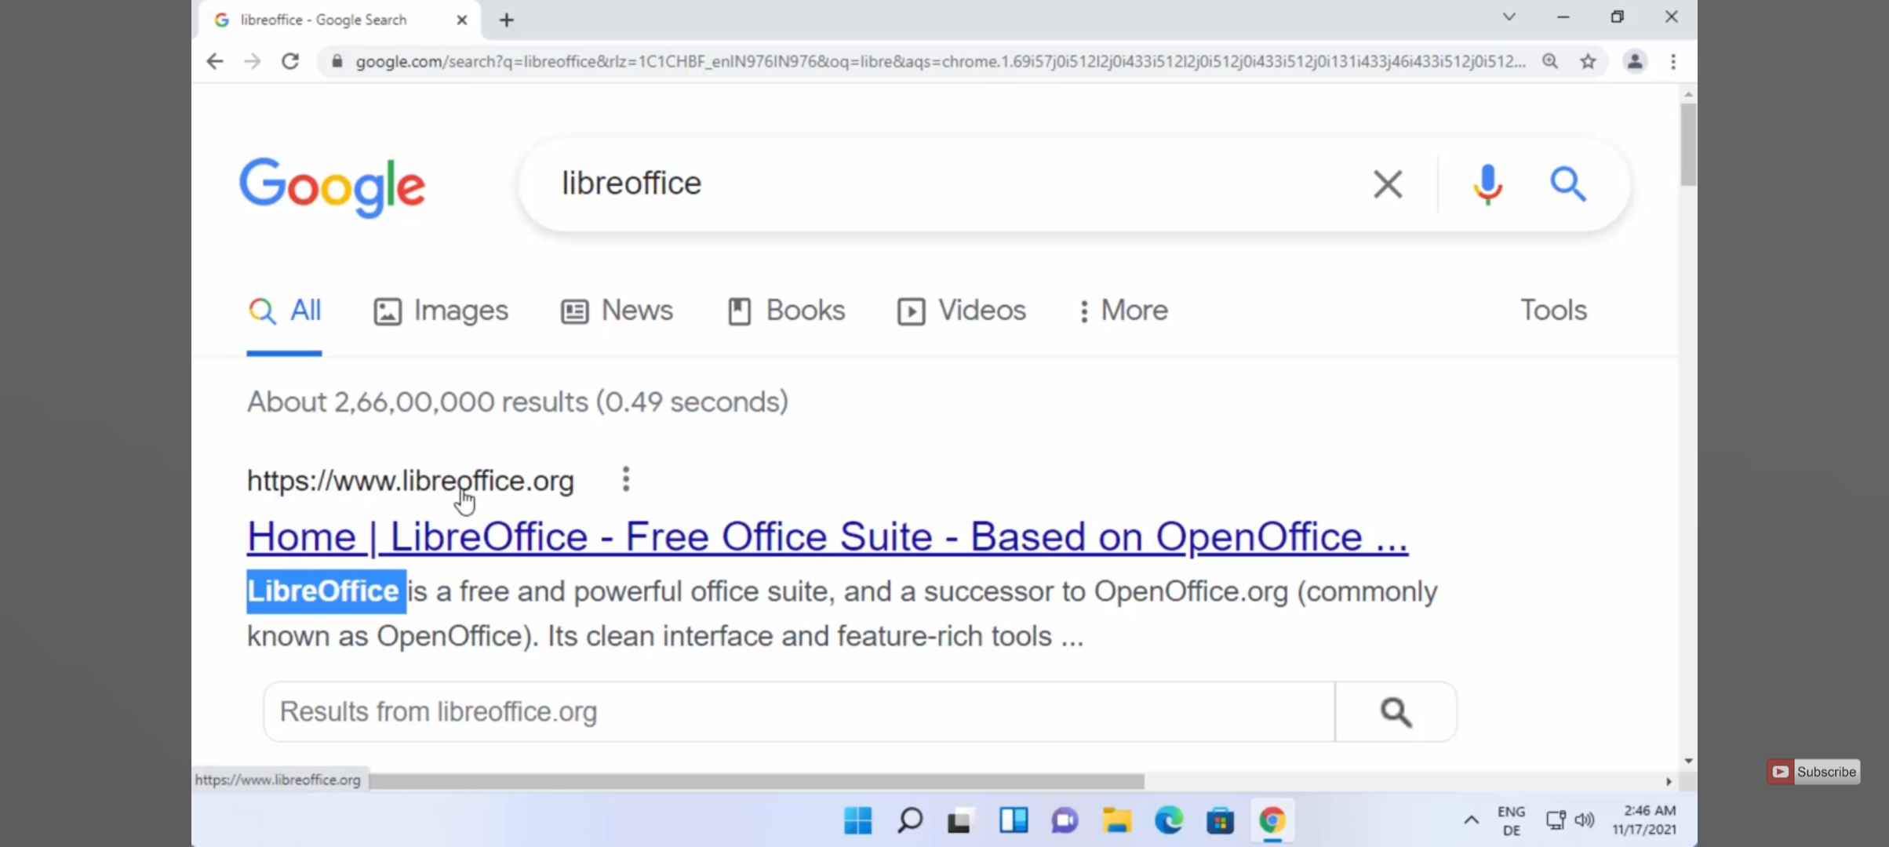

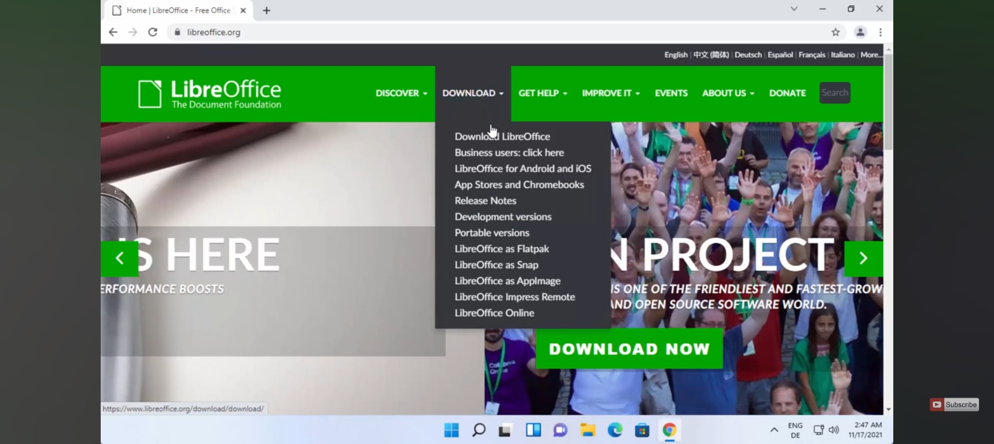

2. Create a Bootable Media:

* For CD/DVD: Burn the ISO to a CD using software like ImgBurn, Brasero, or any ISO burning tool.
* For USB: Use a tool like Rufus or UNetbootin to create a bootable USB drive from the ISO.

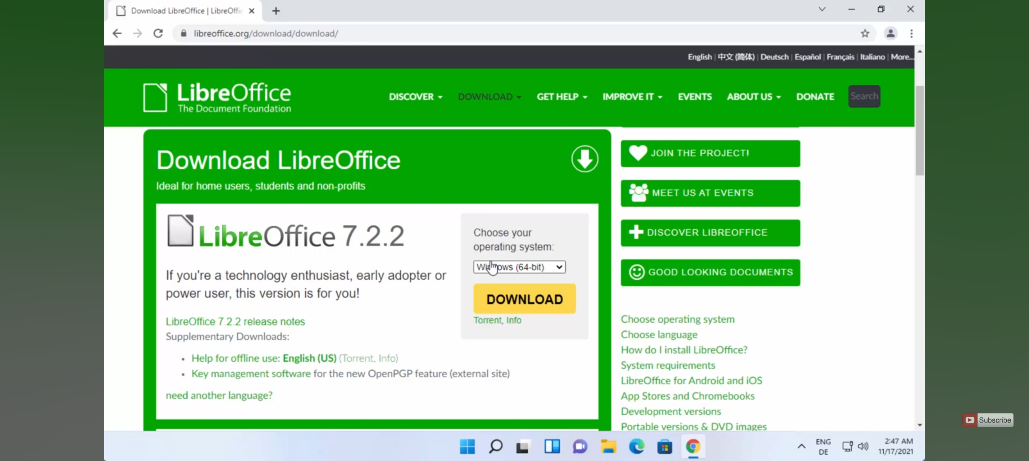

3. Insert the bootable CD or USB into your computer, restart, and boot from it. You may need to enter the BIOS/UEFI settings to change the boot order.

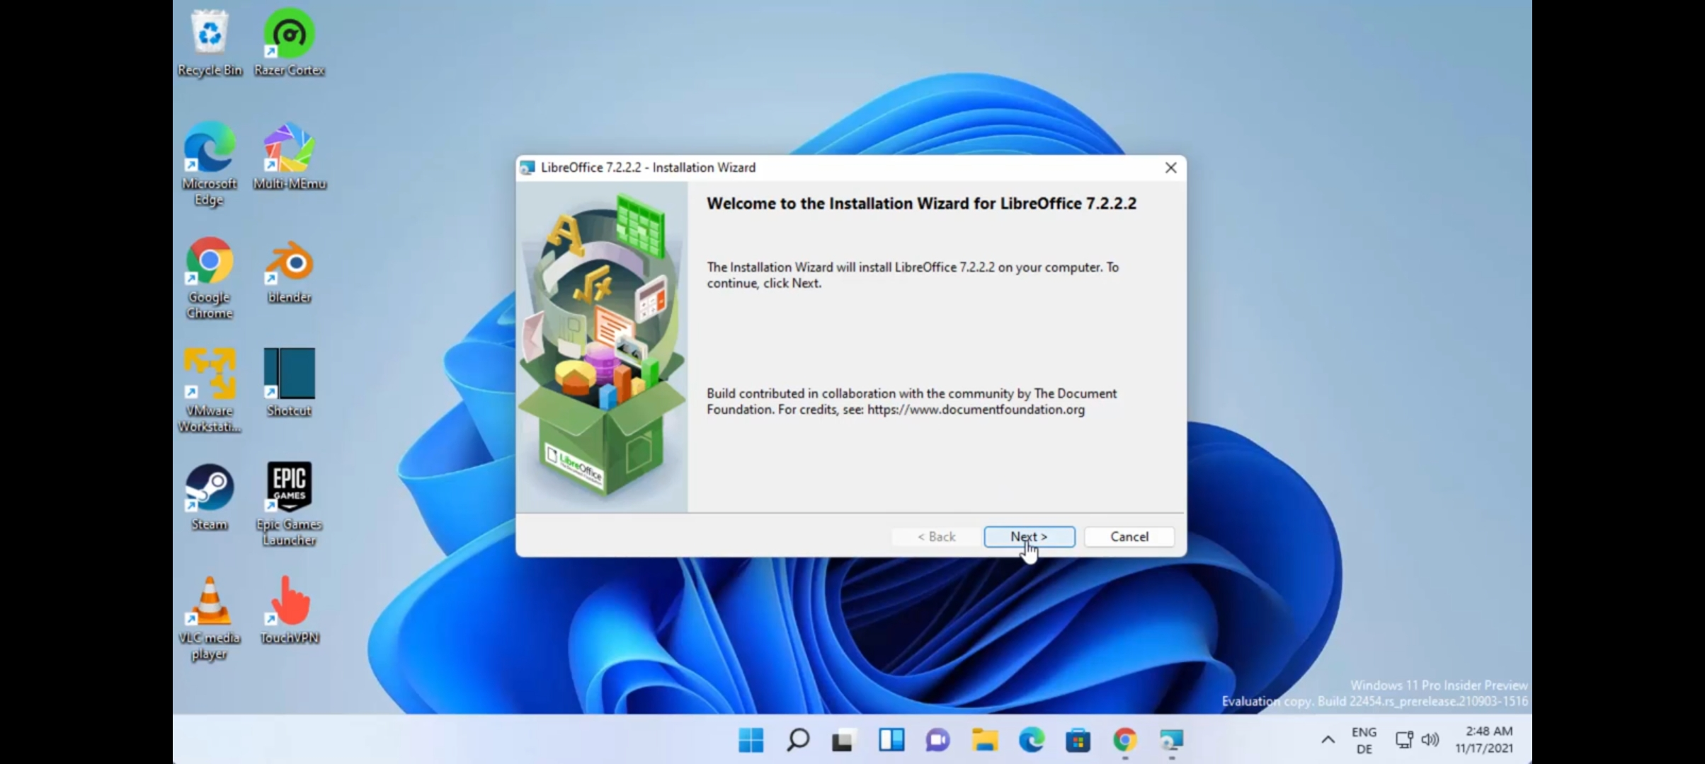

4. Start the Installation:

* Once the system boots:
* You'll enter the Syllable live environment.
* Launch the installer (usually found on the desktop or in the system menu).
* Follow the guided steps to partition your hard drive and install the OS.

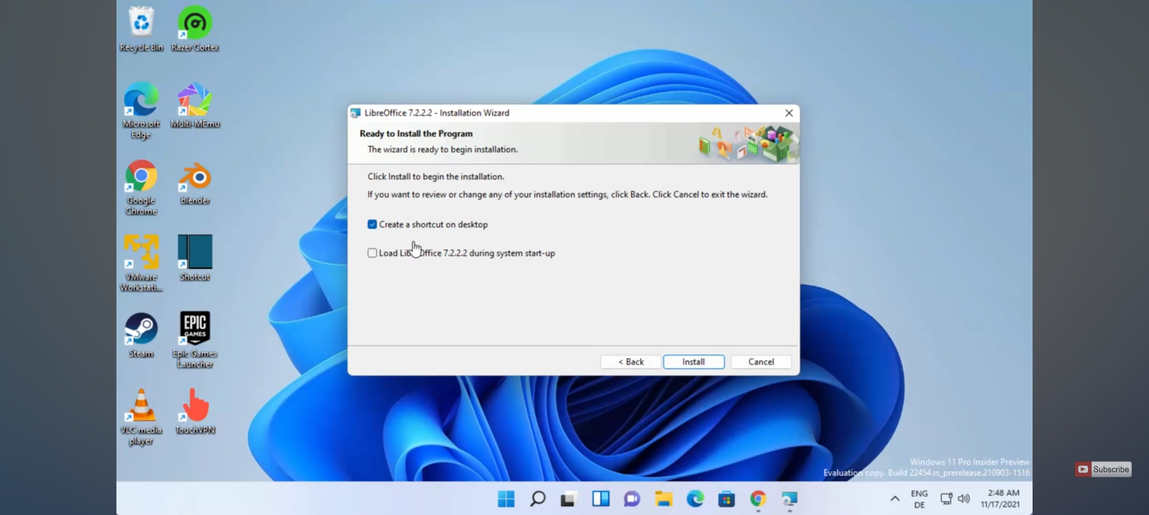

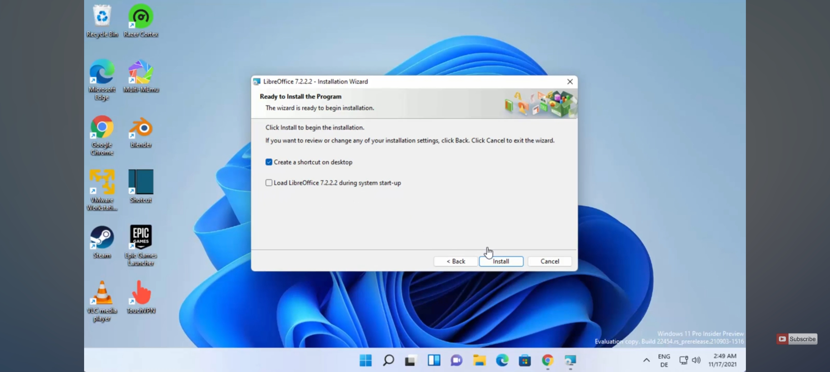

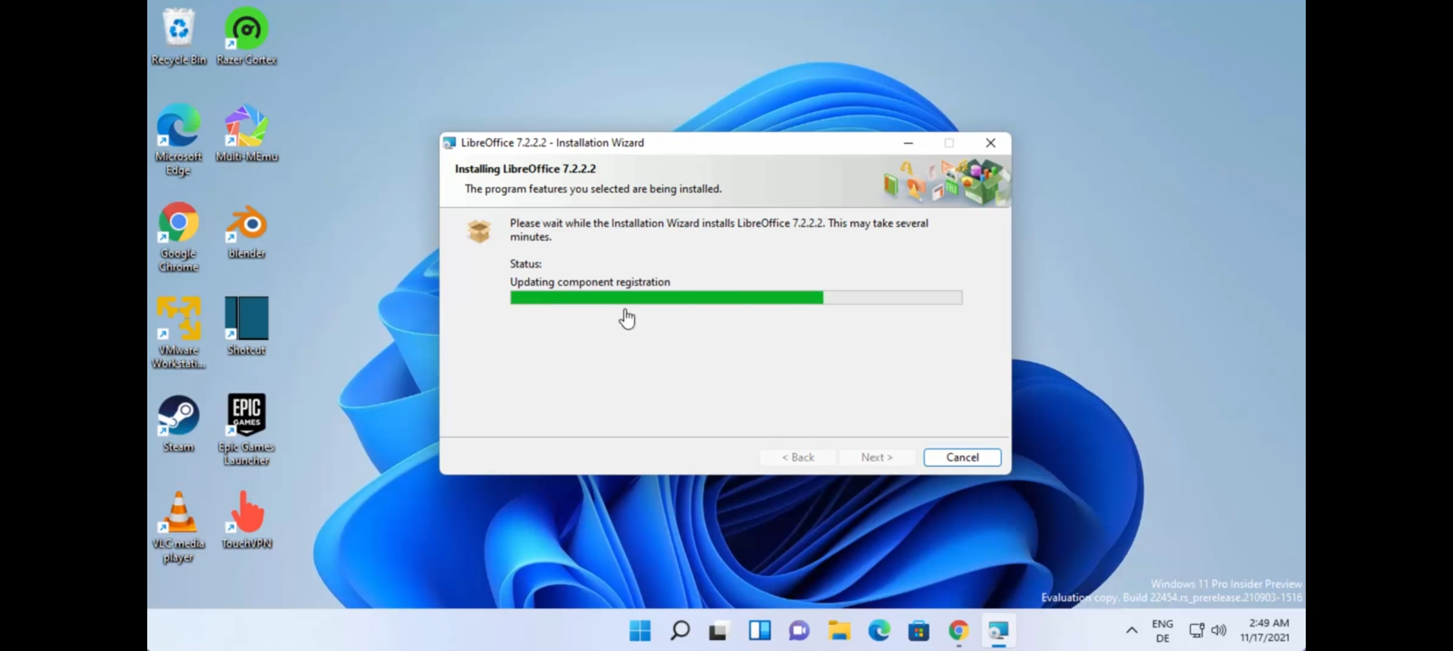5. Finish & Reboot:

* Once installed, reboot the system, remove the installation media, and boot into Syllable OS from your hard drive.

---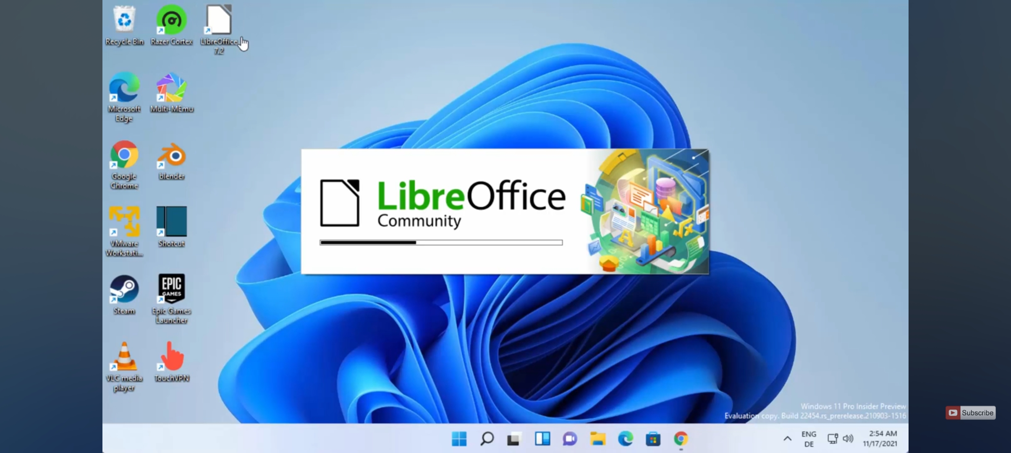

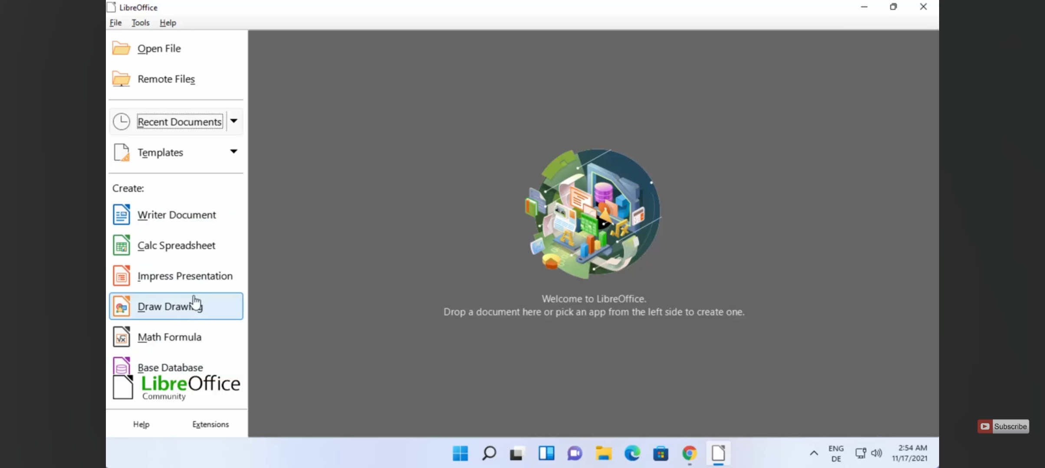

Conclusion

The Syllable Operating System embodies a deliberate trade-off between feature-richness and lean efficiency. By implementing its own micro-kernel architecture and adhering to essential POSIX standards, Syllable delivers a responsive, low-overhead environment ideally suited to hobbyists, embedded systems developers, and those seeking a minimalist desktop OS. Its compact codebase and modular design facilitate rapid boot times, straightforward debugging, and easy customization—attributes that

contrast sharply with the growing complexity of mainstream operating systems.

However, Syllable’s niche positioning carries inherent challenges. Its smaller developer and user communities translate into fewer prebuilt applications, limited commercial support, and a slower pace of driver development. These factors can raise the barrier to entry for less-technical users and constrain the OS’s viability for more demanding, resource-intensive workloads. Yet, this very scarcity also fosters a tight-knit ecosystem of enthusiasts who contribute focused enhancements, ensuring that Syllable remains a proving ground for innovative OS ideas rather than a victim of feature bloat.

Looking forward, Syllable’s long-term success hinges on balancing community growth with its founding principles of simplicity and speed. Strategic partnerships—with open-source projects, hardware vendors, or academic institutions—could enrich its software repository and broaden hardware compatibility without sacrificing its lightweight ethos. Ultimately, Syllable stands as a compelling case study in operating-system design: a reminder that, even in an era of ever-expanding OS feature sets, there remains enduring value in the elegance of simplicity.

FUTURE OUTLOOK

The future of the Syllable Operating System depends heavily on community engagement, technological relevance, and the ability to adapt to modern computing demands. While Syllable has not seen rapid development in recent years, it retains potential as a lightweight, open-source alternative for specialized environments such as embedded systems, legacy hardware, educational tools, or minimalist computing.

To remain viable, Syllable must focus on:

1. Community Growth: Encouraging more developers and users to contribute can help revive momentum. Open-source projects thrive on active communities, and Syllable would benefit greatly from forums, documentation, and collaborative development.

2. Modern Hardware Support: Updating drivers and expanding hardware compatibility will be essential to ensure Syllable can run efficiently on newer systems.

3. Application Ecosystem: Enhancing software availability through package management tools or compatibility layers could improve its usability and attract a broader user base.

4. Niche Applications: Syllable may find success in targeted roles such as digital kiosks, hobbyist projects, or IoT devices where a full-featured OS is unnecessary or too resource-intensive.

While the mainstream desktop market may be dominated by larger players, Syllable's minimalist design and open architecture position it well for innovation in low-resource and specialized computing scenarios. With renewed development efforts and strategic direction, Syllable can continue to serve as a valuable platform for experimentation and lightweight computing.

Virtualization

Virtualization allows operating systems like Syllable to run in a controlled environment on top of another host OS, providing flexibility for testing, development, and deployment without needing dedicated hardware. Although Syllable OS is designed as a lightweight system, it can be successfully virtualized using popular platforms such as VirtualBox, VMware, or QEMU.

Key Considerations:

1. Lightweight Architecture: Syllable’s small footprint makes it ideal for virtualization, as it uses minimal system resources and boots quickly.

2. Use Cases: Virtualizing Syllable is particularly useful for:

* Developers testing applications in a controlled environment.
* Educational purposes to demonstrate OS design and architecture.
* Preserving legacy systems or experimenting with alternative OS features.

3. Compatibility: Since Syllable does not receive frequent updates, compatibility with newer virtualization tools may require manual configurations (e.g., setting proper video or network drivers in the VM settings).

4. Performance: While Syllable performs well in virtual environments due to its efficiency, certain hardware features may not be fully supported unless properly configured in the virtualization software.

Virtualization enhances the accessibility and usability of Syllable OS, making it easier to explore and experiment with its features without the need for dedicated physical hardware. This also provides a safe platform for developers and researchers to work with an alternative operating system model without disrupting their primary systems.